SIMATS
B.E. ELECTRONICS AND COMMUNICATION ENGINEERING

ENGINEERING DESIGN ASSIGNMENT
CO4 – ANALOG AND DIGITAL COMMUNICATION

MODULATION AND MULTIPLEXING FOR A RURAL DIGITAL RADIO LINK
AN ENGINEERING INVESTIGATION REPORT

Submitted by
LOKESH A
Register Number: 192512293

Degree: B.E. Electronics and Communication Engineering (ECE)
Course Code: ECA0801
Course Title: Analog and Digital Communication
Assignment: CO4
Submitted to: Department of Electronics and Communication Engineering

ABSTRACT
This report investigates a rural digital microwave backhaul link connecting a village aggregation node to an optical-fibre point-of-presence (PoP), together with a short-range agricultural sensor link. The study follows the CO4 assignment stages: traffic-rate interpretation and experiment planning; signal-space comparison of BPSK, QPSK, 8-PSK, 8-QAM, 16-QAM and 64-QAM; clear-sky/rain-fade feasibility; TDM/FDM multiplexing and node switching; Monte Carlo BER and carrier-phase impairment investigation; constant-envelope sensor modulation; and QAM use in 4G/5G. Calculations use the assignment’s 5 MHz channel, raised-cosine roll-off factor 0.25, C/N₀ values of 91 and 82 dB-Hz, and stated BER targets. Python-generated simulation figures are included and labelled as finite-sample results. Unspecified implementation details are stated as design assumptions rather than presented as measured facts.

TABLE OF CONTENTS
- 1. Problem interpretation and investigation plan
- 2. Signal-space investigation of candidate modulation schemes
- 3. Backhaul link feasibility and adaptive modulation strategy
- 4. Multiplexing, frame structure and node switching design
- 5. Simulation-based BER and practical impairment investigation
- 6. Sensor-link constant-envelope modulation
- 7. QAM in 4G and 5G systems
- 8. Final engineering decision and specification verification
- References
- Appendix A – Python simulation method and source code

1. PROBLEM INTERPRETATION AND INVESTIGATION PLAN

1.1 Engineering problem and given requirements
A rural connectivity programme aggregates voice, school/health-centre data and agricultural Internet of Things (IoT) sensor traffic at a village node. The node must multiplex this traffic and transmit it over a licensed point-to-point microwave link to an optical-fibre PoP. The assignment specifies two link conditions: clear sky and worst-case monsoon rain fade. The design must protect always-on services while carrying as much school/health-centre data as the channel permits.
Parameter | Given requirement | Design interpretation
Digitised voice | 30 channels × 64 kb/s | 1.920 Mb/s; real-time and always on
School/health data | 4 independent streams × 2 Mb/s ± 50 ppm | 8.000 Mb/s nominal; best-effort under fade
Agricultural IoT | 120 sensors × 4.8 kb/s | 0.576 Mb/s; delay-tolerant but always on
Backhaul RF bandwidth | 5 MHz | Raised-cosine roll-off α = 0.25
Clear-sky C/N₀ | 91 dB-Hz | Available for at least 99% of the time
Rain-fade C/N₀ | 82 dB-Hz | Worst case up to 1% of the time
Backhaul BER | ≤ 10⁻⁶ | Demodulator output target
Required operating margin | ≥ 3 dB | Above Eb/N₀ required for BER = 10⁻⁶
Sensor link | 1 MHz; 120 × 4.8 kb/s; BER ≤ 10⁻³ | Battery-powered saturated PA; low-cost non-coherent receiver preferred

1.2 Payload-rate calculations
The payload rate is the sum of the independent traffic-source rates. Framing, synchronisation, justification and forward error correction (FEC) are additional overheads and are not included in the raw payload figures.
Traffic category | Calculation | Payload rate
Voice | 30 × 64 kb/s | 1.920 Mb/s
School/health data | 4 × 2 Mb/s | 8.000 Mb/s
Agricultural IoT | 120 × 4.8 kb/s | 0.576 Mb/s
Full traffic | 1.920 + 8.000 + 0.576 | 10.496 Mb/s
Always-on traffic | 1.920 + 0.576 | 2.496 Mb/s

Therefore, the link must carry 10.496 Mb/s when all traffic is present. Voice and IoT together form the mandatory traffic floor of 2.496 Mb/s. School/health data is the traffic class that may be reduced or suspended during severe fading, subject to the service agreement.

1.3 Maximum symbol rate and required bandwidth efficiency
For raised-cosine pulse shaping, the approximate null-to-null RF bandwidth is B = Rₛ(1 + α), where Rₛ is the symbol rate and α = 0.25. Hence Rₛ,max = 5 MHz / 1.25 = 4 Msymbol/s.
Requirement | Calculation using 5 MHz | Minimum efficiency
Full traffic | 10.496 Mb/s ÷ 5 MHz | 2.0992 bit/s/Hz
Always-on traffic | 2.496 Mb/s ÷ 5 MHz | 0.4992 bit/s/Hz

The 4 Msymbol/s ceiling gives uncoded raw bit-rate ceilings of 4, 8, 12, 12, 16 and 24 Mb/s for BPSK, QPSK, 8-PSK, 8-QAM, 16-QAM and 64-QAM respectively. These are theoretical ceilings before framing/FEC overhead. The actual selected line rate must be below the ceiling.

1.4 Relationship between C/N₀, bit rate and Eb/N₀
For a receiver with bit rate Rᵦ, Eb/N₀ = C/N₀ ÷ Rᵦ. In decibel form: (Eb/N₀) dB = (C/N₀) dB-Hz − 10 log₁₀(Rᵦ in bit/s). Thus a fixed received C/N₀ does not imply a fixed Eb/N₀: a higher transmitted bit rate divides the received carrier energy among more bits and reduces energy per bit. Modulation order also determines how many bits are carried per symbol and therefore the rate that fits a given symbol-rate limit.
Illustrative line rate | Clear-sky available Eb/N₀ | Rain-fade available Eb/N₀
10.600 Mb/s (full-frame design rate) | 91 − 10log₁₀(10.6×10⁶) = 20.75 dB | 82 − 10log₁₀(10.6×10⁶) = 11.75 dB
2.600 Mb/s (mandatory-service frame rate) | 91 − 10log₁₀(2.6×10⁶) = 26.85 dB | 82 − 10log₁₀(2.6×10⁶) = 17.85 dB

The two line rates above are rounded design examples including modest framing allowance. Final margins must be calculated at the actual implemented line rate. A candidate that cannot support the required bit rate is infeasible regardless of its Eb/N₀ margin.

1.5 Constraints unique to the sensor link
- The sensor transmitters are battery-powered, so energy per transmitted bit and sleep/listen time matter.
- The low-cost saturated non-linear power amplifier favours constant-envelope modulation and is poorly suited to high-PAPR amplitude-varying signals.
- The receiver preference is low cost, with non-coherent detection preferred where feasible.
- All 120 sensors share only 1 MHz; multiple-access timing/frequency accuracy and collision control are necessary.
- The sensor BER target is 10⁻³ with packet retransmission, less stringent than the backhaul target of 10⁻⁶.

1.6 Research questions, hypotheses and experimental plan
Research question and prior hypothesis | Independent variable → dependent variable | Controlled variables, method and evidence
RQ1: Which backhaul modulation can carry all traffic with ≥3 dB margin in clear sky? Hypothesis: 16-QAM will be a practical candidate. | Modulation order and traffic rate → capacity, Eb/N₀ margin and BER. | Hold bandwidth, α and C/N₀ fixed. Use signal-space calculations and AWGN BER theory. Confirm if line-rate ceiling and ≥3 dB margin are both met.
RQ2: Can the mandatory voice + IoT traffic survive rain fade? Hypothesis: QPSK can carry the mandatory load. | C/N₀ and line rate → available Eb/N₀ and margin. | Hold channel model and BER target fixed. Use analytical link budget and feasibility matrix. Confirm if mandatory traffic fits and margin ≥3 dB.
RQ3: Which candidate is most sensitive to carrier phase offset? Hypothesis: 16-QAM will be more affected than BPSK/QPSK. | Phase offset (0°, 10°, 20°) → BER and constellation displacement. | Hold bit energy, AWGN and detector method fixed. Run custom Monte Carlo simulation and compare BER/scatter plots.
RQ4: Does phase continuity improve MSK spectral skirts compared with BFSK? Hypothesis: MSK will have faster spectral decay. | Modulation waveform → power spectral density. | Hold bit rate and observation length fixed. Generate equal-rate waveforms and compare PSD plots.
RQ5: Which sensor multiple-access method is practical? Hypothesis: scheduled TDM is simpler for low-cost sensors. | Access method → timing/frequency accuracy and implementation overhead. | Compare analytical bandwidth, guard and synchronisation requirements; verify total sensor rate against 1 MHz.

1.7 Stage 1 decision
The investigation will use a priority-based adaptive backhaul: higher-order modulation in clear sky and a more robust lower-order mode during rain fade. The service policy will preserve voice and IoT first. This hypothesis is revisited after the BER and link-margin calculations in Stages 3 and 5.

2. SIGNAL-SPACE INVESTIGATION OF CANDIDATE MODULATION SCHEMES

2.1 Basis functions and constellation representation
For coherent passband modulation, use two orthonormal basis functions over one symbol interval T: φI(t) = √(2/T) cos(2πfct) and φQ(t) = −√(2/T) sin(2πfct). A symbol is represented by the vector s = IφI + QφQ. The constellation diagrams are plotted in the in-phase (I) and quadrature (Q) plane. All candidates are normalised to the same average energy per bit Eb so their minimum Euclidean distances can be compared fairly.
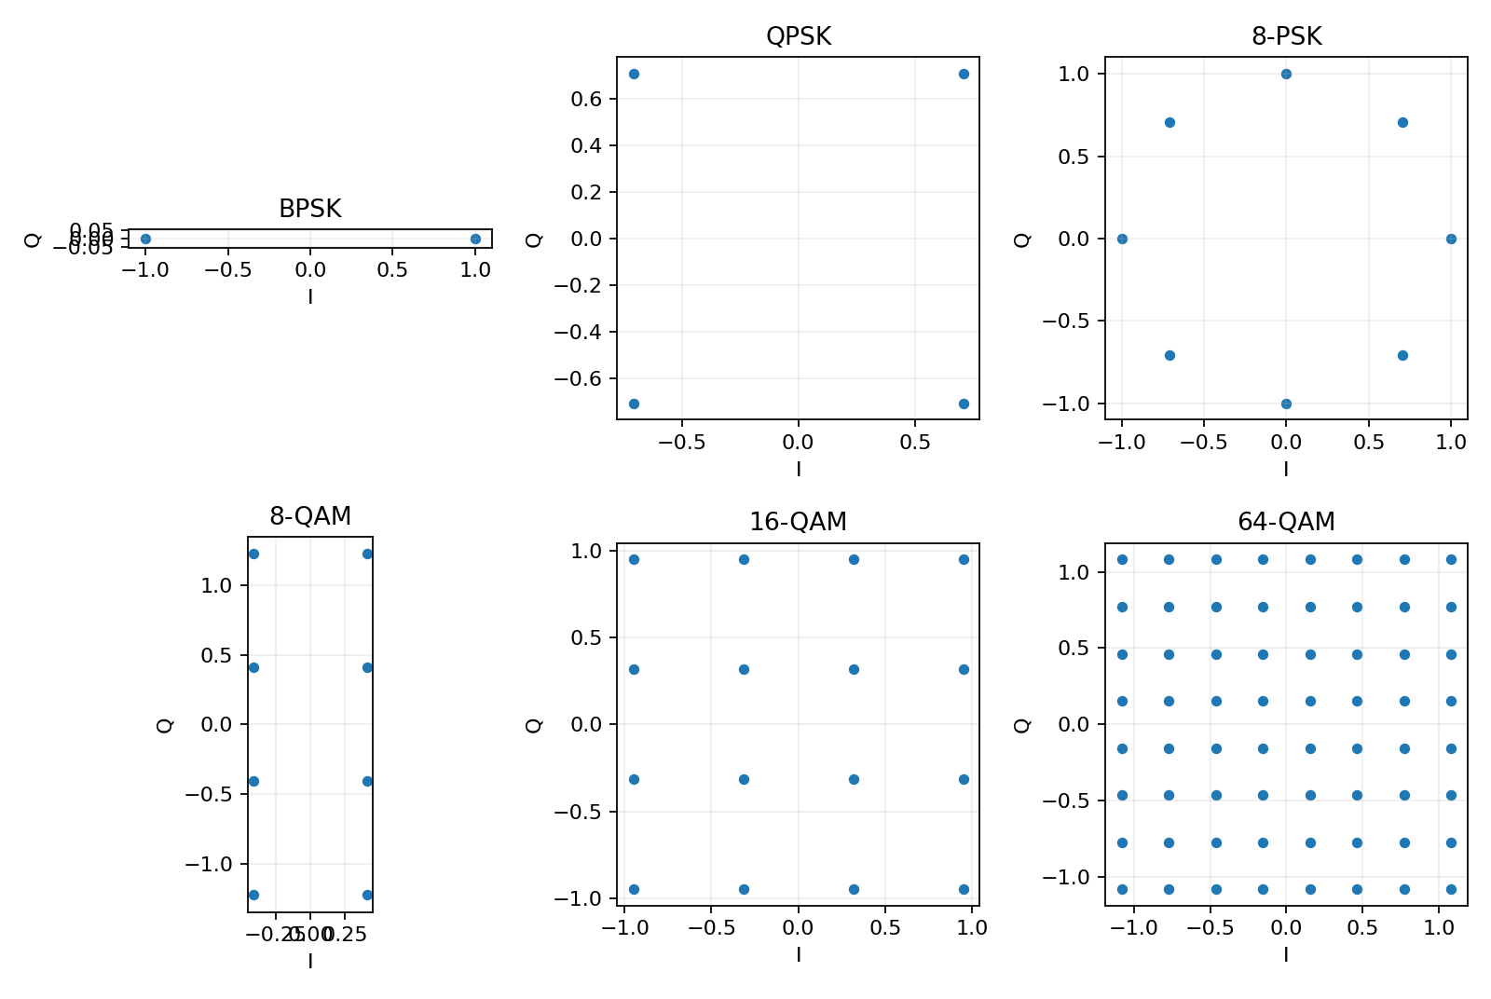
Figure 1. Signal-space constellation geometries for the six candidate schemes.

2.2 Minimum Euclidean distance normalised to Eb
The minimum Euclidean distance dmin is the shortest distance between any two constellation points. A larger dmin/√Eb generally provides better noise tolerance at the same Eb, because the received noisy point can move farther before crossing a decision boundary.
Scheme | Bits/symbol k | dmin/√Eb | Derivation / constellation assumption
BPSK | 1 | 2.000 | Two antipodal points ±√Eb.
QPSK | 2 | 2.000 | Four points on a circle; adjacent separation gives 2√2 sin(π/4).
8-PSK | 3 | 1.326 | 2√3 sin(π/8).
8-QAM | 3 | 1.414 | Rectangular 4×2 constellation: I = ±1, Q = ±1, ±3; Es,avg = 6, Eb = 2, dmin = 2.
16-QAM | 4 | 1.265 | Square 4×4 constellation; dmin/√Eb = √(6k/(M−1)).
64-QAM | 6 | 0.756 | Square 8×8 constellation; dmin/√Eb = √(6k/(M−1)).

For M-PSK, dmin/√Eb = 2√k sin(π/M), where k = log₂M. For square M-QAM, dmin/√Eb = √[6 log₂M/(M−1)]. For the selected rectangular 8-QAM geometry, the average unnormalised symbol energy is 6 and Eb = Es/3 = 2; the nearest neighbours are separated by 2, giving dmin/√Eb = √2.

2.3 Peak-to-average power ratio
Ignoring pulse shaping, the constellation PAPR is the largest symbol energy divided by average symbol energy. Constant-radius PSK constellations have 0 dB symbol PAPR. QAM has multiple symbol radii and therefore a higher peak-to-average ratio.
Scheme | Peak/average symbol energy | PAPR
BPSK | 1 | 1.00 = 0.00 dB
QPSK | 1 | 1.00 = 0.00 dB
8-PSK | 1 | 1.00 = 0.00 dB
8-QAM (4×2 rectangular) | 10/6 | 1.667 = 2.22 dB
16-QAM | 18/10 | 1.800 = 2.55 dB
64-QAM | 98/42 | 2.333 = 3.68 dB

2.4 Spectral efficiency and raw bit-rate ceiling
For raised-cosine shaping, B ≈ Rₛ(1+α). With α = 0.25, the theoretical bandwidth efficiency is η = Rᵦ/B = k/(1+α). The same result is obtained by multiplying the maximum 4 Msymbol/s by the bits per symbol.
Scheme | k | η = k/1.25 (bit/s/Hz) | Maximum raw bit rate in 5 MHz
BPSK | 1 | 0.80 | 4 Mb/s
QPSK | 2 | 1.60 | 8 Mb/s
8-PSK | 3 | 2.40 | 12 Mb/s
8-QAM | 3 | 2.40 | 12 Mb/s
16-QAM | 4 | 3.20 | 16 Mb/s
64-QAM | 6 | 4.80 | 24 Mb/s

2.5 Theoretical Eb/N₀ required for BER = 10⁻⁶
For coherent BPSK and Gray-coded QPSK in AWGN, Pb = Q(√(2Eb/N₀)); solving Pb = 10⁻⁶ gives approximately 10.53 dB. For 8-PSK, a Gray-coded nearest-neighbour approximation is used. For square QAM, the standard nearest-neighbour BER approximation is used. The 8-QAM figure is an approximate nearest-neighbour estimate for the stated rectangular constellation; it is not an exact coded-system threshold.
Scheme | BER model / method | Approx. Eb/N₀ at 10⁻⁶
BPSK | Q(√(2γb)) | 10.53 dB
QPSK | Q(√(2γb)) per bit | 10.53 dB
8-PSK | Gray nearest-neighbour approximation | 13.95 dB
8-QAM | Rectangular 8-QAM nearest-neighbour estimate | ≈13.5 dB (approx.)
16-QAM | Square-QAM nearest-neighbour approximation | 14.40 dB
64-QAM | Square-QAM nearest-neighbour approximation | 18.78 dB

2.6 Why 16-QAM is more power-efficient than 16-PSK
Both schemes carry four bits per symbol, but their geometries are different. For 16-PSK, dmin/√Eb = 2√4 sin(π/16) = 0.780. For square 16-QAM, dmin/√Eb = √(6×4/15) = 1.265. At equal average Eb, the 16-QAM nearest-neighbour distance is substantially larger. The 16-PSK points are constrained to one circle, so adjacent angular spacing becomes small as the order increases. QAM uses both amplitude and phase, placing points on a grid and providing larger nearest-neighbour separation at the same average bit energy. This is why 16-QAM needs less Eb/N₀ for the same target BER, although it requires a more linear amplifier and has higher PAPR.

2.7 Ranked shortlist and Stage 2 decision
Rank for this backhaul | Scheme | Reason
1 | 16-QAM | Carries the full payload with margin in clear sky; moderate PAPR and good spectral efficiency.
2 | 8-PSK / 8-QAM | 12 Mb/s raw ceiling; 8-PSK has constant envelope while 8-QAM has closer amplitude levels.
3 | QPSK | Strong power efficiency and robust rain-fade mode, but 8 Mb/s raw ceiling cannot carry all 10.496 Mb/s.
4 | 64-QAM | Highest capacity, but higher BER threshold and PAPR; clear-sky margin is inadequate at full line rate.
5 | BPSK | Robust but only 4 Mb/s raw ceiling; cannot carry all traffic.

Stage 2 decision: retain 16-QAM for the clear-sky candidate and QPSK for the rain-fade mandatory-service candidate. The shortlist also retains 8-PSK as a comparison scheme in the feasibility and simulation stages.

3. BACKHAUL LINK FEASIBILITY AND ADAPTIVE MODULATION STRATEGY

3.1 Traffic and line-rate design assumptions
The raw payload is 10.496 Mb/s. A clear-sky framed line rate of 10.600 Mb/s is used as a compact illustrative allocation for frame alignment and control; the final system must reserve additional capacity if FEC or extra signalling is implemented. During rain fade, the design preserves 1.920 Mb/s voice and 0.576 Mb/s IoT, with a 2.600 Mb/s framed line rate. All four school/health-centre streams are suspended in this severe-fade profile. These rates are design assumptions used consistently in the feasibility calculations.

3.2 Maximum bit rate and traffic sufficiency
Modulation | Raw maximum rate | Full traffic 10.496 Mb/s? | Mandatory 2.496 Mb/s?
BPSK | 4 Mb/s | No | Yes
QPSK | 8 Mb/s | No | Yes
8-PSK | 12 Mb/s | Yes | Yes
8-QAM | 12 Mb/s | Yes | Yes
16-QAM | 16 Mb/s | Yes | Yes
64-QAM | 24 Mb/s | Yes | Yes

3.3 Available Eb/N₀ and operating margins
At 10.600 Mb/s, the available Eb/N₀ is 20.75 dB in clear sky and 11.75 dB in rain fade. At 2.600 Mb/s, it is 26.85 dB in clear sky and 17.85 dB in rain fade. Margin is calculated as available Eb/N₀ minus the approximate Eb/N₀ required for BER = 10⁻⁶. A positive margin is not sufficient by itself: the candidate must also have enough raw bit-rate capacity.
Scheme | Required Eb/N₀ | Clear margin at 10.6 Mb/s | Rain margin at 10.6 Mb/s | Rain margin at 2.6 Mb/s
BPSK | 10.53 dB | +10.22 dB (rate fails) | +1.22 dB (rate fails) | +7.32 dB
QPSK | 10.53 dB | +10.22 dB (rate fails) | +1.22 dB (rate fails) | +7.32 dB
8-PSK | 13.95 dB | +6.80 dB | +−2.20 dB | +3.90 dB
8-QAM | ≈13.5 dB | +7.25 dB | ≈−1.75 dB | ≈4.35 dB
16-QAM | 14.40 dB | +6.35 dB | −2.65 dB | +3.45 dB
64-QAM | 18.78 dB | +1.97 dB | −7.03 dB | −0.93 dB

Interpretation: 16-QAM can carry the full framed traffic in clear sky and exceeds the operator’s 3 dB margin requirement under the stated uncoded AWGN assumptions. In rain fade, no scheme can carry the full 10.6 Mb/s line rate and maintain the required 3 dB margin. QPSK can carry the mandatory 2.6 Mb/s profile with approximately 7.3 dB margin. The BPSK/QPSK margins shown at 10.6 Mb/s are only diagnostic values; their 5 MHz raw bit-rate ceilings are below the full line rate and they are not feasible for full traffic.

3.4 Feasibility matrix
Scheme | Clear sky – full traffic | Rain fade – full traffic | Rain fade – mandatory traffic
BPSK | Not feasible – rate limited | Not feasible – rate limited | Feasible – 4 Mb/s ceiling and >3 dB margin
QPSK | Not feasible – rate limited | Not feasible – rate limited | Feasible – 8 Mb/s ceiling and >3 dB margin
8-PSK | Feasible – >3 dB margin | Not feasible – negative margin | Feasible – >3 dB margin
8-QAM | Feasible – >3 dB margin | Not feasible – negative margin | Feasible – >3 dB margin
16-QAM | Feasible – >3 dB margin | Not feasible – negative margin | Feasible – approximately 3.45 dB margin
64-QAM | Marginal – <3 dB margin | Not feasible – large negative margin | Not feasible – below 3 dB margin

3.5 Adaptive modulation decisions
Design Decision 1 – Clear sky: I recommend 16-QAM for clear-sky operation because its 16 Mb/s raw ceiling accommodates the 10.6 Mb/s framed stream and the estimated operating margin is about 6.35 dB above the 10⁻⁶ BER threshold, exceeding the required 3 dB.
Design Decision 2 – Rain fade: I recommend QPSK, carrying the 30 voice channels and 120-sensor IoT aggregate, because its 8 Mb/s raw ceiling is sufficient for the 2.6 Mb/s mandatory-service profile and its estimated margin is about 7.32 dB. All four 2 Mb/s school/health data streams are suspended during the worst-case fade.
The alternative of retaining 16-QAM during rain is rejected because the available Eb/N₀ at the full line rate is below its 10⁻⁶ threshold by approximately 2.65 dB, even before the required 3 dB operating reserve. 64-QAM is rejected because its higher required Eb/N₀ makes it less robust. A fixed QPSK scheme is rejected for normal operation because its 8 Mb/s ceiling cannot carry the full 10.496 Mb/s payload. Adaptive modulation with explicit traffic priority is therefore required.

3.6 Limitation and engineering implication
The result is conditional on uncoded coherent AWGN estimates, exact received C/N₀ values and ideal synchronisation. Practical FEC can improve BER at a given Eb/N₀ but adds redundancy and processing latency. The design must include a measured link budget, rain-fade statistics, antenna alignment, amplifier back-off and implementation loss before field commissioning.

4. MULTIPLEXING, FRAME STRUCTURE AND NODE SWITCHING DESIGN

4.1 TDM versus FDM
Criterion | Time Division Multiplexing (TDM) | Frequency Division Multiplexing (FDM)
Allocation | Traffic sources occupy assigned time slots in one digital stream. | The 5 MHz channel is split into separate frequency sub-channels.
Guard/framing overhead | Frame-sync, control and optional guard-time overhead. | Guard bands between sub-channels reduce usable spectrum.
Spectral efficiency | High when slots are filled and framing is compact. | Reduced by guard bands and independent channel filtering.
Adaptive modulation | One carrier and one frame can be remapped during fade. | Different sub-bands may require independent modulation and power control.
Synchronisation | Requires frame and slot timing; elastic buffers handle source-clock offsets. | Requires frequency accuracy, filtering and channel separation.
Complexity | Digital framing, buffering and time-slot switching. | Multiple RF filters/oscillators and frequency planning.

I recommend synchronous TDM multiplexing because all traffic can share one carrier, priority-based slots can be retained or removed during rain fade, and the digital node can perform time-slot interchange for voice rerouting. FDM would consume guard-band spectrum and complicate adaptive modulation on a single licensed 5 MHz channel.

4.2 Proposed 1 ms frame structure
Use a 1 ms frame (1,000 frames/s). Each 64 kb/s PCM voice channel contributes 64 bits per frame. The 120 sensor streams contribute 120 × 4.8 = 576 kb/s, or 576 bits per 1 ms frame. Each school/health stream contributes nominally 2,000 bits per frame. Four independent streams therefore contribute 8,000 nominal bits per frame.
Frame field | Bits per 1 ms frame | Purpose
Frame synchronisation and control | 100 | Frame alignment, signalling and reserved control capacity (design assumption).
Voice slots – 30 × 64 kb/s | 1,920 | All 30 voice channels; always retained.
IoT sensor aggregate | 576 | 120 × 4.8 kb/s; always retained.
School/health stream 1 | 2,000 nominal | Independent 2 Mb/s source; elastic buffer and justification.
School/health stream 2 | 2,000 nominal | Independent 2 Mb/s source; elastic buffer and justification.
School/health stream 3 | 2,000 nominal | Independent 2 Mb/s source; elastic buffer and justification.
School/health stream 4 | 2,000 nominal | Independent 2 Mb/s source; elastic buffer and justification.
Justification opportunities | 4 | One per independent data stream per frame.
Total clear-sky frame | 10,600 bits | 10.600 Mb/s line rate.

The 100-bit synchronisation/control field and one justification opportunity per data stream are explicit design allocations, not values stated by the question paper. The actual justification-control bits must be encoded in a defined protocol and included in the line-rate budget. The illustrative clear-sky line rate is 10.6 Mb/s, below the 16 Mb/s 16-QAM raw ceiling.

4.3 Rain-fade frame remapping
Frame field | Clear-sky allocation | Rain-fade allocation | Action
Sync/control | 100 bits | 100 bits | Retain
30 voice channels | 1,920 bits | 1,920 bits | Retain all voice slots
IoT aggregate | 576 bits | 576 bits | Retain all sensor payload
Four school/health streams | 8,000 nominal bits | 0 payload bits | Suspend/drop during worst-case fade
Total | 10,600 bits | 2,600 bits | Switch to QPSK

The frame controller announces the active profile using protected signalling. The receiver must know the frame version and slot map before the transition. Buffering may preserve a short burst of school/health data, but indefinite buffering is not possible if the fade persists; the service policy must permit back-pressure or temporary suspension.

4.4 Independent 2 Mb/s clocks and bit justification
Each school/health stream has an independent clock of 2 Mb/s ± 50 ppm. The maximum fractional deviation is 50 × 10⁻⁶. The maximum rate difference per stream is 2,000,000 × 50 × 10⁻⁶ = 100 bit/s. Over a 1 ms frame, the maximum excess or deficit is 100 × 0.001 = 0.1 bit/frame. A single justification opportunity per frame provides up to 1,000 bit/s of adjustment capacity per stream if a one-bit positive or negative justification decision is permitted each frame. This exceeds the 100 bit/s maximum drift.
An elastic FIFO absorbs short-term phase differences. A stuffing/justification control indicator tells the receiver whether a frame contains a payload bit or a justification bit. The multiplexer must monitor FIFO occupancy and avoid buffer overflow/underflow. The same arrangement is not needed for the synchronous 8 kHz voice source if it shares the node reference clock.

4.5 Time-slot interchange (TSI) switch
The node must route any of 30 incoming voice channels to any outgoing voice time slot. For 30 channels sampled at 8 kHz, one voice time-slot frame occurs every 125 μs. A simple TSI stores one 8-bit PCM sample from each channel in a data memory and uses a control memory to read them out in the selected order.
TSI quantity | Calculation | Result
Data memory per 125 μs frame | 30 channels × 8 bits | 240 bits = 30 bytes
Control memory | 30 output slots × 5 address bits | 150 bits = 18.75 bytes
Memory cycle rate | 30 accesses in 125 μs | 240,000 accesses/s
Maximum access interval | 125 μs / 30 | 4.167 μs per slot
Space-division crosspoints | 30 inputs × 30 outputs | 900 crosspoints

A practical implementation uses dual-port or banked memory so incoming samples can be written while the previous frame is read. The control memory requires 5 bits per output slot because 2⁵ = 32 addresses, enough to select any of the 30 inputs. The TSI uses compact memory and programmable control, whereas a 30×30 space-division crossbar requires approximately 900 crosspoints and more physical switching paths. The TSI introduces memory access and frame-timing constraints but is generally more flexible for digital voice routing.

4.6 Block-level architecture
Proposed signal path: 30 PCM voice inputs → TSI switch → voice slots; four independent school/health streams → elastic FIFOs and bit-justification logic → data slots; 120 sensor reports → sensor gateway/aggregation → IoT slots; all slots → priority TDM frame builder → adaptive FEC/modulator → raised-cosine pulse shaping → 5 MHz microwave RF chain. At the PoP, the receiver performs carrier/timing recovery, demodulation, FEC decoding, frame alignment, de-multiplexing and delivery to the optical-fibre network.
SOURCE / INPUT | AGGREGATION / SWITCHING | BACKHAUL TRANSMITTER
30 × PCM voice channels | TSI switch → protected voice slots | TDM frame builder → FEC / adaptive modulator → RF
4 × 2 Mb/s data streams | Elastic FIFO → justification → data slots | 16-QAM clear / QPSK rain profile
120 × 4.8 kb/s sensors | Sensor gateway → IoT aggregation | Priority scheduler → 5 MHz microwave link

4.7 Stage 4 decision
Use synchronous TDM with a 1 ms frame, priority-preserving rain remapping, elastic buffers and bit justification for the four independent data clocks. Use a 30-channel TSI for flexible voice-slot routing. The clear-sky 10.6 Mb/s frame fits the 16-QAM ceiling; the 2.6 Mb/s rain frame fits the QPSK ceiling.

5. SIMULATION-BASED BER AND PRACTICAL IMPAIRMENT INVESTIGATION

5.1 Simulation method and limitations
The assignment requires an original Monte Carlo chain: random bit source → custom symbol mapping → complex AWGN addition → custom hard-decision demodulator → error counter. The provided Python implementation uses NumPy for bit generation, mapping, noise and detection, and SciPy/Matplotlib for theoretical references and plots. It evaluates BPSK, QPSK and 16-QAM as three representative schemes. The finite-trial plots are not treated as proof of a BER of 10⁻⁶ unless enough errors and bits have been accumulated.
Simulation setting | Value / explanation
Schemes | BPSK, QPSK and 16-QAM
Eb/N₀ sweep | 0 to 20 dB in 2 dB increments for AWGN
Monte Carlo sample count | 120,000 bits per point in the illustrative run
Channel | Complex AWGN; independent Gaussian I and Q components
Detection | Coherent hard-decision detection with ideal timing
Theory overlay | Analytical uncoded AWGN reference curves
Random seed | 42 for repeatability
Impairment | Uncompensated carrier phase offset: 0°, 10° and 20°

5.2 Experiment A – BER validation in AWGN
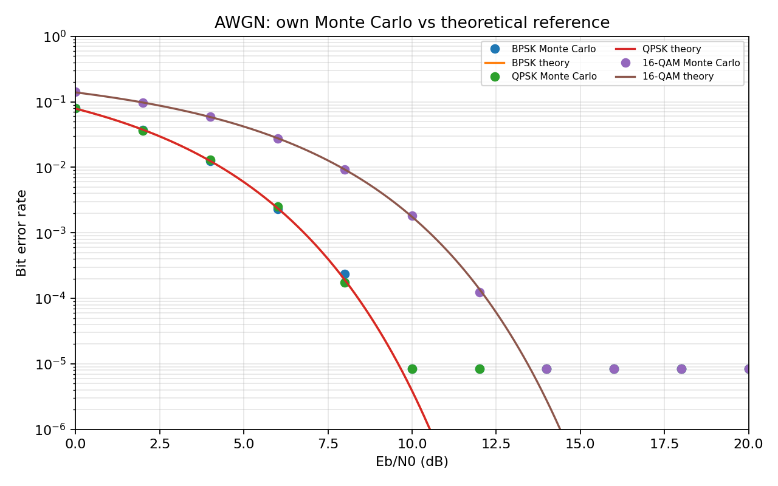
Figure 2. Finite-trial Monte Carlo BER estimates with analytical AWGN reference curves.
The theoretical BPSK and QPSK curves overlap in bit-error probability under ideal coherent AWGN detection because Gray-coded QPSK decomposes into two orthogonal BPSK decisions. 16-QAM requires a higher Eb/N₀ for the same BER because its constellation points are closer together at equal average bit energy. The Monte Carlo markers fluctuate around the theoretical curves because the number of transmitted bits is finite.
At high Eb/N₀, the observed number of errors can be zero in a 120,000-bit run even when the true BER is non-zero. A zero-error run does not prove BER = 0. A common 95% confidence approximation is that zero observed errors gives an upper bound near 3/N; with N = 120,000, this is about 2.5×10⁻⁵, which is not sufficient to verify a 10⁻⁶ target.

5.3 Number of bits required for a reliable BER estimate
For a BER estimate p, the expected number of errors is Np. To observe about 100 errors at p = 10⁻⁶ requires approximately N = 100/10⁻⁶ = 10⁸ bits. Even this is a statistical estimate, not a guarantee. Direct brute-force simulation at every Eb/N₀ point is expensive. Therefore, the 10⁻⁶ requirement is assessed using analytical uncoded AWGN expressions and the calculated link margin, while Monte Carlo is used to validate the implementation in the BER range supported by the finite run. Importance sampling or validated semi-analytical methods could be used for deeper-tail verification.

5.4 Experiment B – Carrier phase offset
A constant carrier phase error rotates each received symbol by θ before the AWGN is added. The impairment experiment uses θ = 0°, 10° and 20°. Eb/N₀ is defined using the transmitted symbol energy before rotation, so the impairment does not artificially redefine the signal energy. The receiver is intentionally assumed to have no phase correction in this experiment.
Prior hypothesis: 16-QAM will be more sensitive than BPSK/QPSK because its decision regions are closer and its rectangular grid is rotated relative to the receiver’s fixed I/Q axes. BPSK/QPSK also suffer from phase error, but their simpler geometry generally gives more tolerance to small phase offsets.
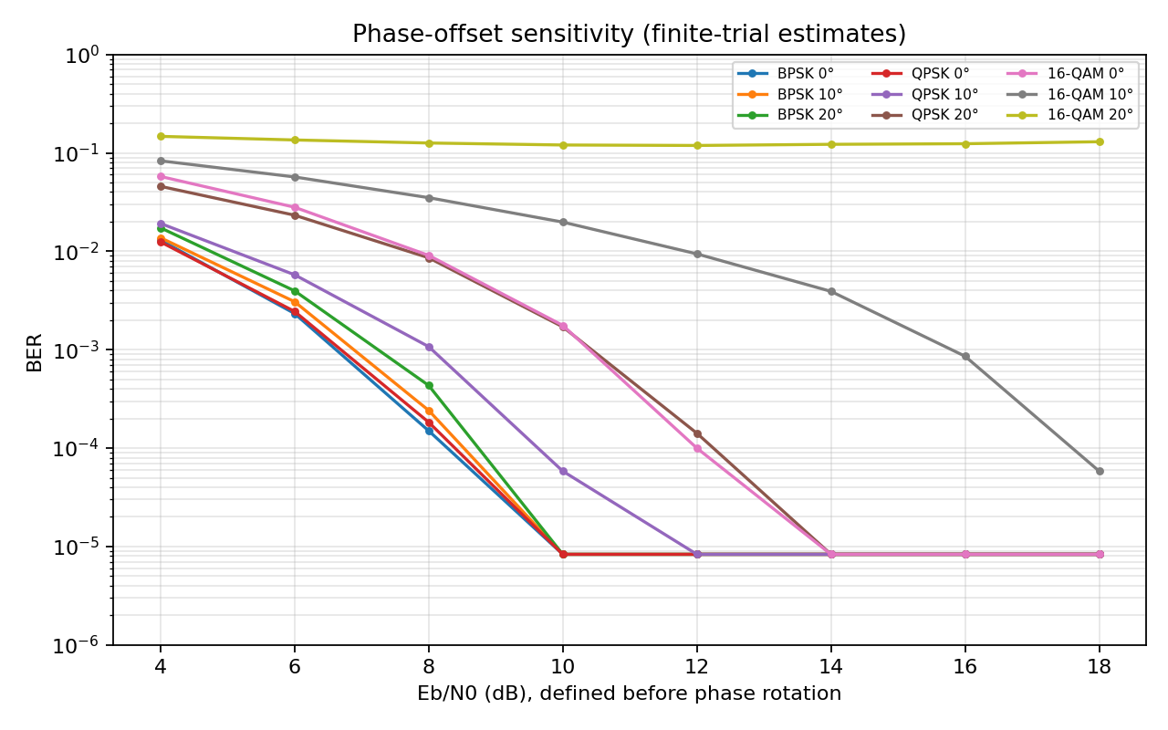
Figure 3. BER against Eb/N₀ for uncompensated carrier phase offsets.
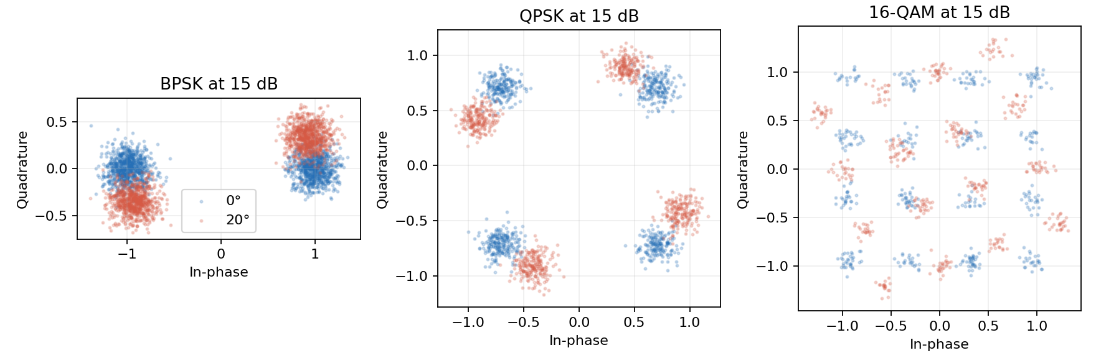
Figure 4. Received constellations at 15 dB with 0° and 20° carrier phase offsets.

5.5 Interpretation of impairment results
The scatter diagrams show the received constellation rotated away from the ideal decision axes as phase offset increases. At 20°, some points move closer to or across fixed decision boundaries; the effect is especially visible for 16-QAM because inner and outer decision regions are more closely spaced. The BER curves therefore degrade as phase offset increases. In a practical receiver, a carrier-recovery loop estimates and removes this rotation; the uncompensated experiment represents residual phase error, not a correctly synchronised receiver.
The finite sample count and coarse 2 dB sweep do not support a precise Eb/N₀ penalty at BER = 10⁻⁴ for every scheme/offset. A defensible penalty requires a denser sweep near 10⁻⁴ and enough observed errors at each point. The plots are therefore used qualitatively to compare sensitivity; no unsupported numerical penalty is claimed. The 1 dB tolerance cannot be certified from these coarse data.

5.6 Revisit of Design Decisions 1 and 2
The impairment experiment supports the need for carrier synchronisation and an operating margin. It does not overturn the adaptive strategy: 16-QAM remains the clear-sky choice only when carrier recovery is functioning and residual phase error is controlled; QPSK remains the rain-fade mode for the mandatory traffic. A practical implementation should include a phase-locked carrier recovery loop, pilot symbols or training sequences, and an alarm/profile downgrade when residual error exceeds the receiver limit.

5.7 Stage 5 decision
The original Monte Carlo chain and plots provide an implementation check and demonstrate the effect of phase error. The 10⁻⁶ BER target is supported by analytical reference curves and link-margin calculations, not by claiming that 120,000 simulated bits directly verified a one-in-a-million error rate.

6. SENSOR-LINK CONSTANT-ENVELOPE MODULATION

6.1 Sensor link requirements
The sensor link aggregates 120 battery-powered transmitters, each sending 4.8 kb/s, in a shared 1 MHz band. The total raw sensor payload is 120 × 4.8 kb/s = 576 kb/s. The transmitters use low-cost saturated non-linear power amplifiers, the BER target is 10⁻³ with retransmission of lost packets, and the receiver should be low cost with non-coherent detection preferred where feasible.

6.2 Modulation comparison
Scheme | Envelope / PA compatibility | Detection | Approx. Eb/N₀ at BER 10⁻³ | Main consideration
ASK / OOK | Variable envelope; amplitude distortion from saturation is harmful. | Simple envelope detection possible. | Depends on OOK convention and detector; typically worse than coherent BPSK. | Very simple, but PA nonlinearity and amplitude noise affect decisions.
Non-coherent BFSK | Constant envelope; well suited to saturated PA. | Non-coherent frequency/energy detection. | 10.94 dB using Pb = 0.5 exp(−Eb/(2N₀)). | Low receiver complexity; wider spectrum than MSK.
MSK | Constant envelope and continuous phase. | Usually coherent; differential/non-coherent variants possible with performance trade-off. | Coherent MSK has BPSK-equivalent ideal BER ≈ 6.79 dB. | Excellent spectral compactness and phase continuity; more receiver complexity.
BPSK | Constant envelope at ideal symbol points; practical pulse shaping can vary envelope. | Coherent carrier detection. | 6.79 dB using Pb = Q(√(2Eb/N₀)). | Good power efficiency; carrier recovery required.

For coherent BPSK and ideal coherent MSK, Pb = Q(√(2Eb/N₀)); solving Pb = 10⁻³ gives approximately 6.79 dB. For non-coherent orthogonal BFSK, Pb = 0.5 exp(−Eb/(2N₀)); solving gives 10.94 dB. These values are theoretical AWGN references and exclude coding gain, oscillator errors, implementation loss and packet retransmission overhead.

6.3 Constant envelope and saturated power amplifiers
A saturated power amplifier is efficient near its output-power limit but distorts amplitude variations. ASK/OOK intentionally carries information in amplitude, so clipping can destroy the distinction between symbols. BPSK and ideal BFSK/MSK use a constant symbol envelope and can tolerate amplifier saturation more naturally. MSK is particularly attractive because its phase changes continuously, avoiding abrupt phase discontinuities and reducing out-of-band spectral splatter.

6.4 Power spectral density: BFSK and MSK
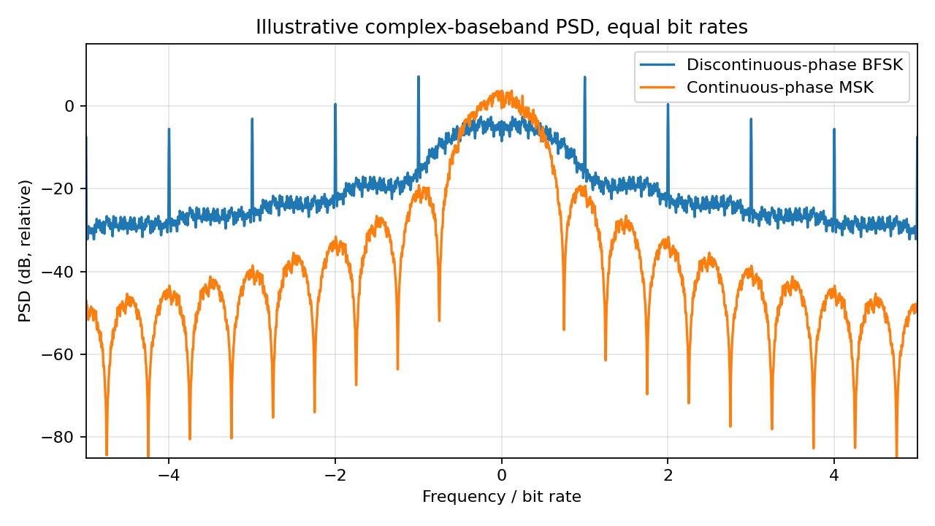
Figure 5. Illustrative equal-bit-rate complex-baseband PSD comparison of discontinuous-phase BFSK and continuous-phase MSK.
The PSD comparison is generated from equal-bit-rate waveforms. MSK maintains continuous phase across bit transitions; this smooth phase trajectory reduces abrupt waveform changes and generally produces lower spectral sidelobes than a discontinuous-phase FSK implementation. The exact PSD depends on frequency deviation, pulse shaping, observation window and implementation. The figure is an illustrative numerical comparison, not a regulatory emission mask.

6.5 TDM or FDM for 120 sensors
Criterion | TDM sensor access | FDM sensor access
Spectrum | All sensors share the same carrier/band at different scheduled times. | Each sensor or group receives a separate sub-band.
Timing/frequency accuracy | Needs time synchronisation and guard intervals; low-cost clocks can be managed by gateway scheduling. | Needs accurate carrier frequency and channel filters; oscillator error can cause adjacent-channel interference.
Receiver cost | One shared receiver chain can serve scheduled packets. | May require channelisation/filter bank or multiple receiver paths.
Collision control | Central scheduling and assigned slots prevent collisions when synchronised. | Frequency planning separates users but requires frequency allocation and control.
Flexibility | Slots can be reassigned as traffic changes. | Sub-band reallocation is less flexible and guard bands consume spectrum.

The aggregate payload is 576 kb/s, which is below the 1 MHz allocation. I recommend centrally scheduled TDM for the 120 sensors, with non-coherent BFSK as the robust low-cost baseline. The gateway assigns time slots, includes guard time for clock uncertainty and acknowledges packets; lost packets are retransmitted. A more spectrally efficient MSK option may be considered if coherent/phase tracking cost and power are acceptable.
Design Decision 4: I recommend non-coherent BFSK with scheduled TDM multiplexing for the sensor link because the constant envelope is compatible with saturated battery-powered amplifiers, the receiver can avoid precise carrier-phase recovery, and 576 kb/s of raw sensor traffic can be scheduled within the 1 MHz shared band. MSK is the preferred upgrade if lower spectral sidelobes justify the extra receiver complexity.

6.6 Stage 6 decision
Use non-coherent BFSK plus centrally scheduled TDM as the conservative low-cost sensor architecture. Keep packet retransmission, CRC, gateway time synchronisation and sleep scheduling in the design. Validate the actual occupied bandwidth and battery energy per successful delivered bit on hardware before deployment.

7. QAM IN 4G AND 5G SYSTEMS

7.1 Modulation orders in LTE and 5G NR
4G LTE uses QPSK, 16-QAM and 64-QAM in common modulation configurations; later LTE releases and applicable channels/configurations support 256-QAM. 5G NR supports QPSK, 16-QAM, 64-QAM and 256-QAM, with additional modulation options such as π/2-BPSK for specified uplink use. The exact supported order depends on release, channel, UE capability and configuration; the system does not always use its highest available order.

7.2 Channel quality reporting and MCS selection
The base station estimates downlink quality from reference signals and channel-state information reported by the user equipment. In LTE/NR, the UE reports channel quality information (CQI) and related measurements; the scheduler selects a modulation and coding scheme (MCS) based on expected channel quality, target block-error rate, available resources and implementation limits. A high CQI can support higher-order QAM and a higher code rate. A low CQI leads to QPSK or another robust mode and a lower code rate. Link adaptation therefore trades throughput against reliability as the channel changes.

7.3 Why π/2-BPSK is included in 5G NR uplink
π/2-BPSK rotates the BPSK constellation by alternating π/2 phase increments between symbols. This produces a waveform with favourable envelope properties for the specified uplink transform-precoded transmission, helping reduce peak-to-average power ratio and easing the power-amplifier efficiency problem in a handset. This connects to Stage 6: battery-powered transmitters with constrained non-linear amplifiers benefit from modulation/waveform choices that avoid large envelope fluctuations.

7.4 Difference between cellular link adaptation and this rural backhaul
Both systems adapt modulation to channel quality, but the control granularity differs. LTE/NR commonly selects an MCS dynamically per scheduled transmission interval and resource allocation using CQI, HARQ feedback and scheduler policy. The rural backhaul proposal uses a simpler link-wide profile switch between 16-QAM clear-sky operation and QPSK rain-fade operation, accompanied by a predefined TDM frame remapping that suspends school/health data while preserving voice and IoT. Cellular systems also use standardised coding, reference signals and retransmission procedures; the proposed rural link needs its own validated framing, FEC, signalling and switching implementation.

7.5 References supporting Stage 7
The discussion is based on the 3GPP LTE and NR physical-layer specifications and technical descriptions of link adaptation. Exact modulation availability must be checked against the relevant release and channel configuration.
- 3GPP TS 36.211, Evolved Universal Terrestrial Radio Access (E-UTRA); Physical Channels and Modulation.
- 3GPP TS 38.211, NR; Physical Channels and Modulation.
- 3GPP TS 38.214, NR; Physical Layer Procedures for Data.
- 3GPP TS 36.213, E-UTRA; Physical Layer Procedures.

7.6 Stage 7 decision
The adaptive-modulation principle in the proposed microwave link is consistent with the broader LTE/NR practice of matching modulation and coding to channel quality. The rural design is simpler and uses service-priority remapping at the same time as modulation downgrade.

8. FINAL ENGINEERING DECISION AND SPECIFICATION VERIFICATION

8.1 Commissioning recommendation
FINAL DECISION: NO – do not commission the design unconditionally in its present form.
The proposed architecture is suitable as an adaptive prototype, but unconditional commissioning is not recommended. Clear-sky calculations show that 16-QAM can carry the 10.6 Mb/s framed traffic with an estimated 6.35 dB margin. During the worst-case rain fade, the full traffic profile cannot meet the BER and 3 dB margin requirement. The QPSK rain profile can preserve the 30 voice channels and 120-sensor IoT aggregate at approximately 2.6 Mb/s, but all four school/health data streams are suspended. This conflicts with a strict interpretation that the four data streams should always be available; the assignment says to carry as many streams as conditions permit, so the service-level policy must explicitly accept temporary suspension.

8.2 Final specification-verification table
Requirement | Specified | Achieved – clear sky | Achieved – rain fade | Satisfied?
Payload bit rate carried | Full traffic | 10.496 Mb/s payload (10.6 Mb/s framed) | 2.496 Mb/s mandatory payload (2.6 Mb/s framed) | Clear: Yes; Rain: Partial
Voice and IoT carried | At all times | 30 voice + 120 sensors | 30 voice + 120 sensors | Yes, subject to outage-free transition
Number of data streams carried | 4 | 4 × 2 Mb/s | 0 during worst-case fade | Clear: Yes; Rain: No
Backhaul BER | ≤10⁻⁶ | Analytical AWGN design target; Monte Carlo is finite-sample validation | Analytical AWGN design target for QPSK profile | Conditional; hardware test required
Operating margin | ≥3 dB | 16-QAM ≈6.35 dB at 10.6 Mb/s | QPSK ≈7.32 dB at 2.6 Mb/s | Yes, under stated assumptions
Sensor link BER | ≤10⁻³ | BFSK theoretical requirement ≈10.94 dB Eb/N₀ | Same sensor link requirement | Not verified without measured sensor C/N₀

8.3 Redesign required before commissioning
- Obtain formal operator approval for rain-fade priority: voice and IoT remain active, while school/health streams are paused or rate-limited during severe fading.
- Add a specified FEC scheme and interleaver to the backhaul. Recalculate the net payload rate, code rate, latency and Eb/N₀ threshold using the selected code.
- Increase fade resilience by evaluating antenna gain, transmit power, receiver noise figure and link availability. Any required C/N₀ improvement must be confirmed by a complete microwave link budget.
- Implement adaptive profile signalling, hysteresis and a minimum dwell time to prevent rapid switching between 16-QAM and QPSK near the fade threshold.
- Measure residual carrier phase error and phase-recovery performance. The Stage 5 finite simulation does not certify the 1 dB impairment-penalty limit.
- Test the sensor link with actual battery-powered nodes, saturated PA operation, packet retransmissions, oscillator tolerance and 1 MHz coexistence.

8.4 Quantified rain-fade shortfall
At the 10.6 Mb/s full-traffic line rate, the rain-fade available Eb/N₀ is approximately 11.75 dB. The 16-QAM approximation requires 14.40 dB for BER = 10⁻⁶, so the link is short by 2.65 dB even before the operator’s additional 3 dB margin is applied. To meet the target with the required reserve, the required available Eb/N₀ is approximately 17.40 dB; compared with 11.75 dB available, the total shortfall is approximately 5.65 dB. This is why the report drops the school/health streams and changes to QPSK during the specified worst-case rain condition.

8.5 Overall conclusion
The investigation demonstrates that modulation choice, symbol geometry, spectral efficiency, BER, amplifier behaviour and multiplexing architecture must be evaluated together. 16-QAM is appropriate for clear-sky high-capacity operation; QPSK is a robust rain-fade profile for the mandatory services; synchronous TDM supports priority remapping and voice switching; non-coherent BFSK with scheduled TDM is a practical sensor-link baseline. The design should proceed to a controlled prototype only after the rain-time service policy, FEC, link budget, receiver phase tracking and sensor hardware tests are completed.

REFERENCES
1. 3GPP TS 36.211, Evolved Universal Terrestrial Radio Access (E-UTRA); Physical Channels and Modulation.
2. 3GPP TS 36.213, Evolved Universal Terrestrial Radio Access (E-UTRA); Physical Layer Procedures.
3. 3GPP TS 38.211, NR; Physical Channels and Modulation.
4. 3GPP TS 38.214, NR; Physical Layer Procedures for Data.
5. J. G. Proakis and M. Salehi, Digital Communications, 5th ed., McGraw-Hill, 2008.
6. B. Sklar, Digital Communications: Fundamentals and Applications, 2nd ed., Prentice Hall, 2001.
7. S. Haykin, Communication Systems, 5th ed., Wiley, 2009.

APPENDIX A – PYTHON SIMULATION METHOD
The simulation chain is: random binary source → Gray mapper → complex AWGN channel → coherent hard-decision demodulator → bit-error counter. The figures in this report were generated using a fixed random seed for repeatability. Theoretical BER curves are separate from Monte Carlo estimates. The finite 120,000-bit run is not sufficient to claim direct verification at BER = 10⁻⁶.

A.1 Reproducibility notes
- Python libraries: NumPy, SciPy and Matplotlib.
- The Monte Carlo implementation generates the random bits, maps symbols, adds AWGN, demodulates and counts bit errors.
- Analytical formulae are used only for theoretical reference curves.
- Phase impairment is applied as a fixed complex rotation before the AWGN channel; the receiver is not given the phase offset.
- The PSD figure uses equal bit-rate waveforms and compares discontinuous-phase BFSK with continuous-phase MSK.
The accompanying source file is intended to make the numerical method reproducible. Numerical results should be regenerated and independently checked before a real equipment design is approved.
# Core Monte Carlo structure (simplified reference)
# 1. Generate random bits.
# 2. Map bits to BPSK, QPSK or Gray-coded 16-QAM symbols.
# 3. Add complex AWGN using the selected Eb/N0.
# 4. Apply optional carrier phase rotation exp(j*theta).
# 5. Make hard decisions using the known constellation.
# 6. Compare detected bits with transmitted bits and estimate BER.
#
# For deep BER targets, increase the bit count substantially.
# A 120,000-bit run cannot directly establish BER = 1e-6.

